**Library Prep Using the “With-Bead” Method**

**Introduction**

This protocol is based on the method of Meyer and Kircher (2010) with modifications to accommodate the capturing of divergent species. It includes a size selection step to select the preferred size of the inserted DNA. Library with larger insert size often results in better coverage uniformity (Harismendy and Frazer, 2009). In phylogenetic studies, the baits used usually are different from the target species. In these cases, longer insert size of the library is particularly useful in obtaining a better coverage of the target regions. The “with-bead” method is also adopted in this protocol to increase the complexity of the library (Fisher et al., 2011). Higher yield of the library was found when using the “with-bead” method than using the regular cleanup methods (Fig. 1).

a)

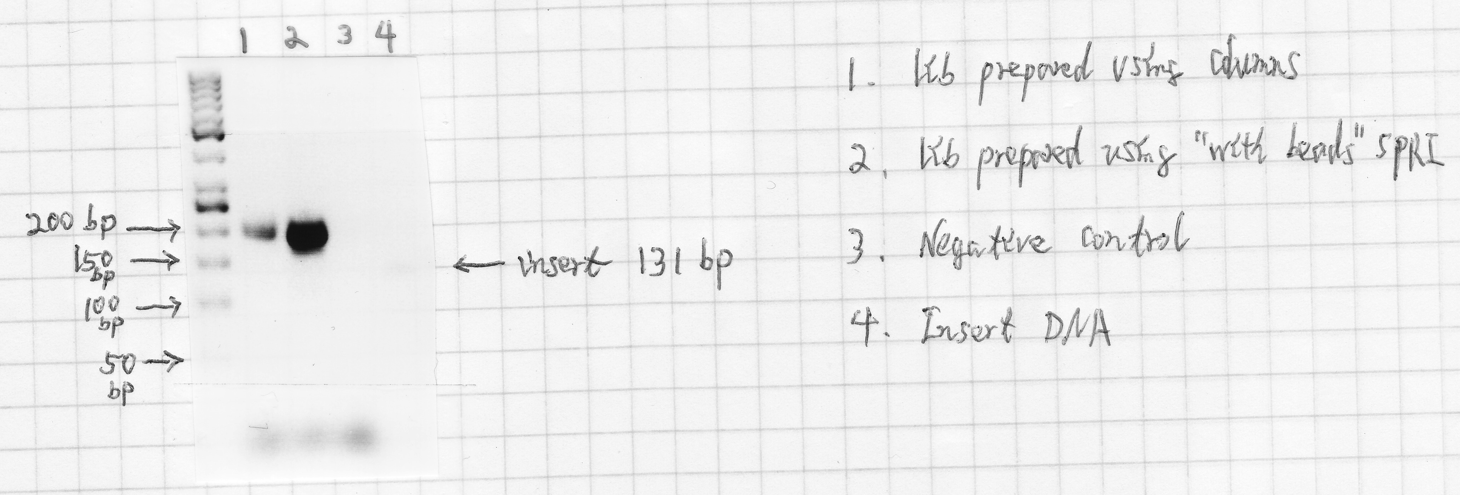

b)

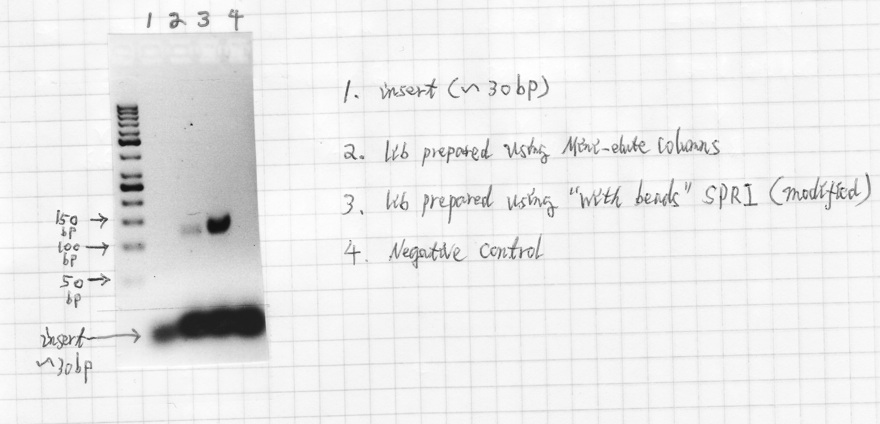

Fig.1. Comparison between “with-bead” library prep method and the common method using columns to clean-up the reaction after each step. a) library with insert size of 131bp; b) library with insert size ~ 30bp.

**Library prep procedure**

I. Shearing the genomic DNA

*Skip the shearing and size selection step if using samples with highly degraded DNA, e.g., ancient DNA or DNA extracted from museum samples.*

1. Start with 0.5 –3μg genomic DNA and shear it to ~ 500bp range using the Covaris machine according to the manufacturer’s instructions (130 μl in Covaris microtube; time: 1 min; temperature: 18 to 22 °C; treatment: 60 sec, Peak Power= 50, Duty Factor= 10, Cycles/Burst = 200).
2. Check the size distribution of the sheared DNA on a mini agarose gel.

II. Size selection

*If the sheared DNA has a broad size distribution, a size selection step may be applied using SPRI beads at different concentration of PEG. The following protocol is used to select DNA that has a size >250 bp. Skip the size selection step if using samples with degraded DNA.*

1. Add 50 μL AMPure XP beads to a 200 μL tube. Use individual tube to avoid cross contamination. “Dry” the beads using a magnetic plate. Please read “*DNA Clean-Up Using Solid Phase Reversible Immobilization (SPRI)*” for how to use the SPRI system.
2. Add 50 μL sheared samples and 37.5 μL 20% PEG to the dried beads (use whatever volume of sample you want, and the desired ratio of PEG that selects the size you want to capture). Prepare one positive and one negative control as the following: Add 50 μL AMPure XP beads to a tube with 30μL nuclease free water and to a tube with 30μL positive DNA (1:100 diluted PCR product of any gene with a size of 100 – 200 bp). Vortex the tubes for several times.
3. Let the tubes set for 10 min, collect the liquid at the bottom of the tube by briefly centrifuging. Place the tube on a magnetic plate, and let it stand for 5-10 min to separate the beads from the solution. Pipette off and discard the supernatant without removing the beads.
4. Leave the tube on the magnetic rack, and wash the beads by adding 186 μL of freshly prepared 70% ethanol. Let stand for 1 min and remove the supernatant. *Keep the tube on the magnetic rack, do not disturb the beads!!!
5. Repeat Step 4 one more time.
6. Remove residual traces of ethanol. Let the beads air-dry for 5 min at room temperature without caps.
7. Proceed to the next step immediately.

III. Blunt-end repair

*If working with ancient DNA or other samples with DNA fragment < 100 bp, skip the size selection step. Concentrate the DNA samples until dry using a speed vac. Then add 20 μL of the master mix to each sample as in the protocol below. After the blunt-end repair, skip step III-3. Instead, incubate the reaction at 75 °C for 20 min to deactivate the enzymes and followed by a ramp decreasing to 12 °C at the rate of 1 °C/s. Immediately proceed to the ligation step.*

1. Prepare a master mix for the number of samples needed as the follow. Add 20 μL of the master mix to each sample. Mix the sample well by brief vortexing.

|  |  |  |  |
| --- | --- | --- | --- |
| Reagent | Volume (μL)  per sample | ×*n* | Final concentration  in 20-μL reaction |
| Buffer Tango (10×) | 2 |  | 1× |
| dNTPs (25 mM each) | 0.08 |  | 100 μM each |
| ATP (100 mM) | 0.2 |  | 1 mM |
| T4 polynucleotide kinase (10 U/μL) | 1 |  | 0.5 U/μL |
| T4 DNA polymerase (5 U/μL) | 0.4 |  | 0.1 U/μL |
| H2O | 16.32 |  |  |

NOTE – we used 10mM dNTP, so per-sample volume is now .2, and 16.2 water

1. Incubate the samples in a thermal cycler for 15 min at 25°C followed by 5 min at 12°C.
2. Add 15 μL 20% PEG (**use desired ratio that was used in size selection step – we will use 15 uL here) to the sample and clean up the reaction according to the SPRI protocol. Keep the dried beads. Proceed immediately to the ligation step.

IV. Adapter ligation

1. Prepare a master mix for the number of samples needed. Add 39 μL of the master mix to each sample tube. Mix the samples well by vortexing.

|  |  |  |  |
| --- | --- | --- | --- |
| Reagent | Volume (μL) per sample | ×*n* | Final concentration in 40-μL reaction |
| T4 DNA ligase buffer (10×) | 4 |  | 1× |
| PEG-4000 (50%) | 4 |  | 5% |
| Adapter mix (50 μM each) | 2 |  | 2.5 μM each |
| H2O | 29 |  |  |

*If working with ancient DNA or other samples with DNA fragments< 100 bp, add 9μL of water instead of 29μL as in the protocol above, then add 19 μL of master mixture to each sample.*

1. Spin down the liquid by brief centrifugation. Add 1 μL T4 DNA ligase (5 U/μL) to the sample. Briefly vortex to mix the sample and collect the liquid at the bottom of the tube by briefly spinning down,then incubate for 30 min at 22°C in a thermal cycler.
2. Cleanup the reaction using the SPRI bead method (adding 30 μL20% PEG for regular library or 80 μL20% PEG for library with short inserts such as ancient DNA or highly degraded museum samples). Keep the dried beads. Proceed immediately to the next step.

V. Fill-in

1. Prepare a master mix for the number of samples needed.

|  |  |  |  |
| --- | --- | --- | --- |
| Reagent | Volume (μL) per sample | ×*n* | Final concentration in 40-μL reaction |
| ThermoPol reaction buffer (BSM buffer 10×) | 4 |  | 1× |
| dNTPs (25 mM each) | 0.4 |  | 250 μM each |
| Bst polymerase (Bsm polymerase), large fragment (8 U/μL) | 1.5 |  | 0.3 U/μL |
| H2O | 34.1 |  |  |

NOTE – we used 10mM dNTP, so per-sample volume is now 1.0, and 33.5 water

1. Add 40 μL of master mix to the samples. Briefly vortex to mix the sample.Collect the liquid at the bottom of the tube by briefly centrifuging.Incubate the samples for 20 min at 37°C.
2. Cleanup the samples using the SPRI bead method (adding 30 μL20%PEG for regular library or 80 μL20%PEG for library with short inserts such as ancient DNA or highly degraded museum samples). Elute the samples with 20 μLof nuclease free water. Transfer the supernatant to a new tube labeled as “sample name + lib”. The libraries can be kept frozen at -20°C for a short period, but it is better to be used as soon as possible to avoid degradation of DNA overtime.

VI. Pre-hybridization PCR

1. Prepare a master mix as the follow for the number of samples needed.

|  |  |  |  |
| --- | --- | --- | --- |
| Reagent | Volume (μL) per sample | ×*n* | Final concentration in 50-μL reaction |
| KAPA HiFitaq Ready Mix (2×) | 25 |  | 1× |
| Primer IS7 (10 μM) | 1.5 |  | 0.3μM |
| Primer IS8 (10 μM) | 1.5 |  | 0.3μM |
| H2O | 16 |  |  |

1. Add 44 μL of master mix to empty tubes, and then add 6 μL of “lib” samples. Mix well and amplify the samples using the following thermal profile: 98 °C for 45sec, 12 to 18 cycles of 98 °C for 15 sec, 65 °C for 30 sec and 72 °C for 45 sec, followed by 72 °C for 1 min, and hold at 4 °C for 10 min. The number of PCR cycles can be adjusted according to the starting material used to construct the library.
2. Cleanup the PCR product using the SPRI bead method (adding 30 μL20% PEG for regular library or 80 μL20% PEG for library with short inserts such as ancient DNA or highly degraded museum samples). Elute the DNA using 20 μL of nuclease free water and transfer it to a new tube labeled as “sample name + preH”. Measure the concentration using Qubit 2.0 Fluorometer. The concentration of the samples should be around 6 - 10ng/μL.

**Recipe for adapter mix**

1. Assemble the following hybridization reactions in separate PCR tubes:

Hybridization mix for adapter P5 (100 μM):

|  |  |  |
| --- | --- | --- |
| Reagent | Volume (μL) | Final concentration in 100-μL reaction |
| IS1_adapter_P5.F (500 μM) | 20 | 100 μM |
| IS3_adapter_P5+P7.R (500 μM) | 20 | 100 μM |
| Oligo hybridization buffer (10×) | 10 | 1× |
| H2O | 50 |  |

Hybridization mix for adapter P7 (100 μM):

|  |  |  |
| --- | --- | --- |
| Reagent | Volume (μL) | Final concentration in 100-μL reaction |
| IS2_adapter_P7.F (500 μM) | 20 | 100 μM |
| IS3_adapter_P5+P7.R (500 μM) | 20 | 100 μM |
| Oligo hybridization buffer (10×) | 10 | 1× |
| H2O | 50 |  |

2. Mix and incubate the reactions in a thermal cycler for 10 sec at 95°C, followed by a ramp from 95°C to 12°C at a rate of 0.1°C/sec. Combine both reactions to obtain a ready-to-use adapter mix(50 μM each adapter).

**Recipe for oligo hybridization buffer (10X)**

|  |  |  |
| --- | --- | --- |
| Reagent | Volume (μL) | Final concentration in 10 ml |
| NaCl (5 M) | 1 ml | 500 mM |
| Tris-Cl, pH 8.0 (1 M) | 100 μL | 10 mM |
| EDTA, pH 8.0 (0.5 M) | 20 μL | 1 mM |
| H2O | 8.88 ml |  |

**Sequences of adapters, and primers**

* indicates a PTO bond

|  |  |
| --- | --- |
| Name | Sequences |
| IS1_adapter.P5 | a*c*a*c*TCTTTCCCTACACGACGCTCTTCCg*a*t*c*t |
| IS2_adapter.P7 | g*t*g*a*CTGGAGTTCAGACGTGTGCTCTTCCg*a*t*c*t |
| IS3_adapter.P5+P7 | a*g*a*t*CGGAa*g*a*g*c |
| IS4_indPCR.P5 | AATGATACGGCGACCACCGAGATCTACACTCTTTCCCTACACGACGCTCTT |
| IS5_reamp.P5 | AATGATACGGCGACCACCGA |
| IS6_reamp.P7 | CAAGCAGAAGACGGCATACGA |
| IS7_short_amp.P5 | ACACTCTTTCCCTACACGAC |
| IS8_short_amp.P7 | GTGACTGGAGTTCAGACGTGT |